**Question on building materials** Name …………………………………………… ESC 2 6/03

1. The diagram shows the formation of some common building materials in terms of the rock cycle.

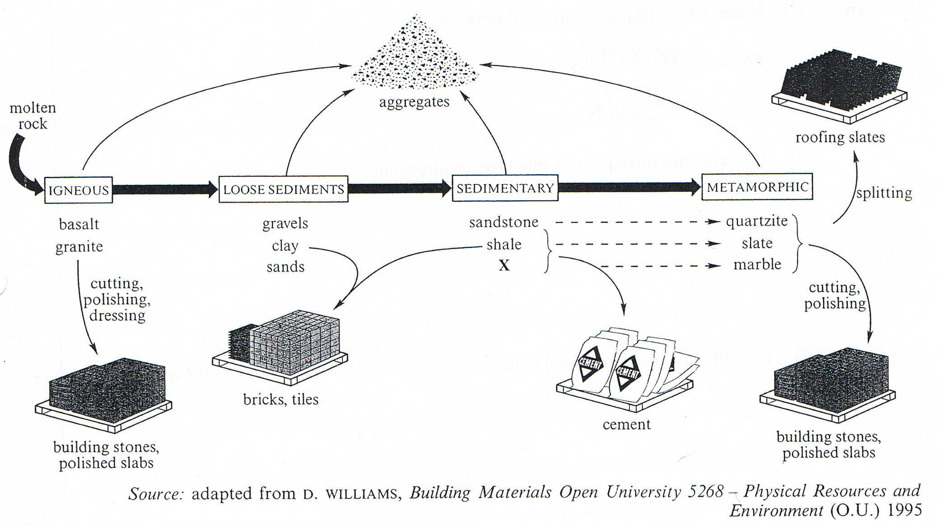

a) Name one geological process involved in the conversion of:

(i) igneous rocks to loose sediments;

………………………………………………………………………………………………

*(1 mark)*

(ii) shale to slate;

………………………………………………………………………………………………

*(1 mark)*

(iii) loose sediments to sedimentary rocks.

………………………………………………………………………………………………

*(1 mark)*

b) Suggest the identity of **X**.

………………………………………………………………………………………………

*(1 mark)*

c) In the building industry, what is meant by the term ‘aggregates’?

………………………………………………………………………………………………

*(1 mark)*

………………………………………………………………………………………………

*Total 5 marks*

**Question on Limestone** Name ………………………………………….

2. Rocks are classified into three major groups according to the way in which they are

formed.

a) (i) Name the group of rocks to which limestone belongs. *(1 mark)*

………………………………………………………………………………………………………..

(ii) Describe the formation of **one** type of limestone. *(2 marks)*

…………………………………………………………………………………………………………

…………………………………………………………………………………………………………

(iii) Describe the environmental conditions necessary for the formation of the type of

limestone you have described in a) part (ii). *(2 marks)*

…………………………………………………………………………………………………………

…………………………………………………………………………………………………………

(iv) Name the most abundant mineral in limestone. *(1 mark)*

…………………………………………………………………………………………………………

(v) What rock is formed when limestone undergoes metamorphosis? *(1 mark)*

…………………………………………………………………………………………………………

b) Identify the properties of limestone and indicate how these make it particularly appropriate for each of **two** major uses in the construction industry. *(4 marks)*

Use 1 …………………………………………………………………………………………………

Properties …………………………………………………………………………………………….

…………………………………………………………………………………………………………

Use 2 …………………………………………………………………………………………………

Properties …………………………………………………………………………………………….

…………………………………………………………………………………………………………

c) Limestone is a non-ore mineral. Explain what is meant by ‘non-ore’ mineral. *(2 marks)*

………………………………………………………………………………………………………...

…………………………………………………………………………………………………………

d) Name an ore mineral, and suggest a use of its product in the construction industry.

*(2 marks)*

Name ……………………………………………… Use …………………………………………

*Total 15 marks*